ISM ANTENNA
Antenna ISM Connector Mount G015,
868 MHz, 2 dBi, SMA(m) 90°
AO-A868-G015-RS

SECTRON company oﬀers a wide portfolio of ISM antennas with various versions diﬀering in shape, level of gain and manner of attachment. SECTRON guarantees a compatible connection between
an antenna and all antenna adaptors produced by SECTRON.

BENEFITS

Low VSWR
Easy installation

AO-A868-G015-RS5
FEATURES
FEATURES
FEATURES

Technology | ISM/LoRa/SIGFOX
Frequency bands | 868 MHz
Bandwidth | -
Gain | 2 dBi
VSWR | <2.0:1
Impedance | 50 Ohm
Directivity | Omnidirectional
Beam angle | H 360° V 30°
Polarization | Linear
Maximum input power | 10 W
Power voltage | -
Dimensions | 87.2 x 16.8 x 9.2 mm
Weight | 8.34g
Operating temperature | -40 to +85 °C
Execution | External
Method of attachment | Connector Mount
Cable type | -
The cable length | -
Connector type | SMA(m)
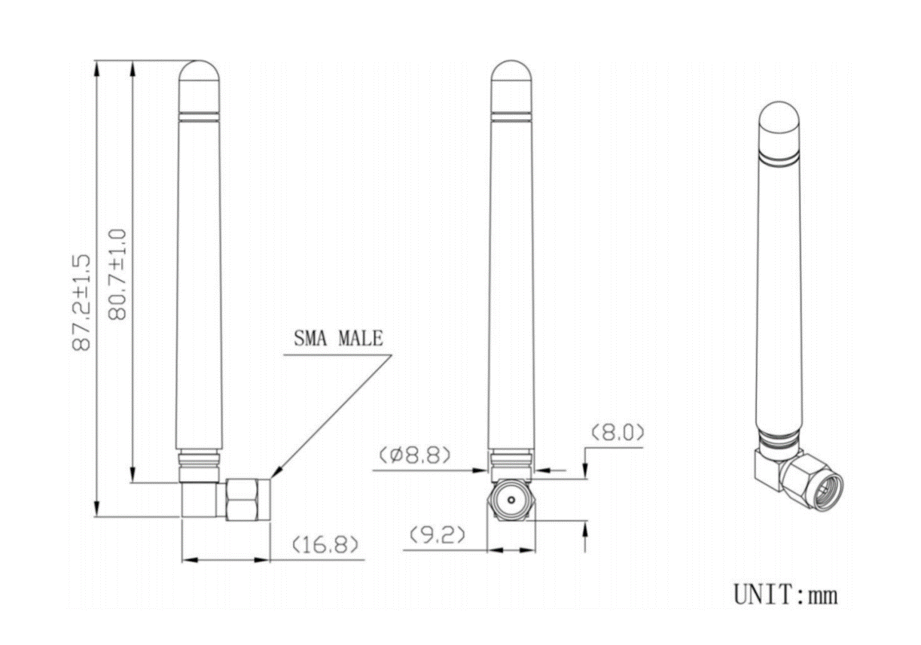
DRAWING

CONTACTS

SECTRON s.r.o. Josefa Šavla 1271/12 | WWW.SECTRON.CZ
709 00 Ostrava 9, Czech Republic | Tel.: +420 556 621 020

AO-A868-G015-RS
FEATURES
ALL VARIANTS

VARIANT | PART NUMBER

CONTACTS

SECTRON s.r.o. Josefa Šavla 1271/12 709 00 Ostrava 9, Czech Republic
WWW.SECTRON.CZ
Tel.: +420 556 621 021

